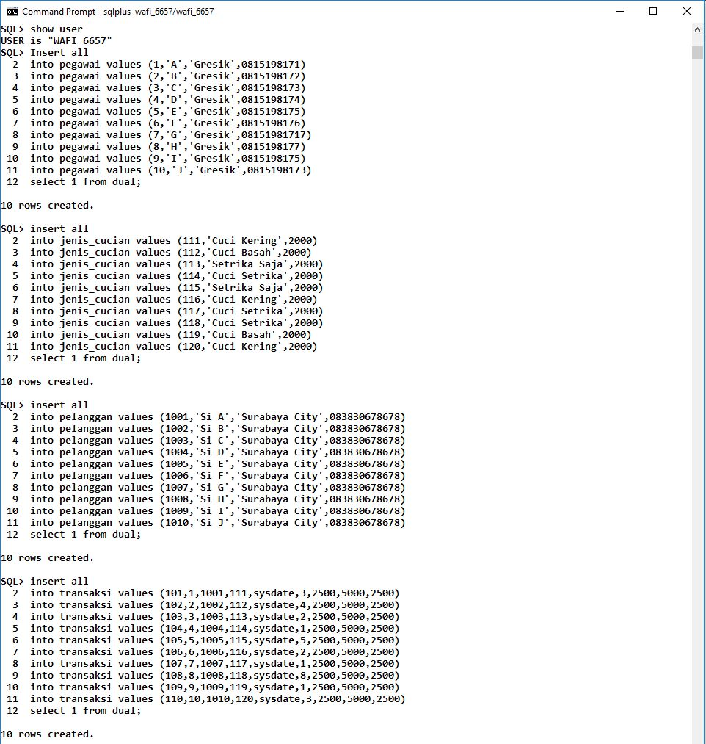

Keterangan Query :

------------------------------------------------------------------------------------------------------------------------------------------------------------------------------------------------------------------------------------------------------------------------------------------------------------------------------------------------------------------------------------------------------------------------------------------------------------------------------------------------------------------------------------------------------------------------------------------------------------------------------------------------------------------------------------------------------------------------------------------------------------------------------------------------------------------------------------------------------------------------------------------------------------------------------------------------------------------------------------------------------------------------------------------------------------------------------------------------------------------------------------------------------------------------------------------------------------------------------------------------------------------------------------------------------------------------------------------------------------------------------------------------------------------------------------------------------------------------------------------------------------------------------------------------------------------------------------------------------------------------------------------------



Keterangan Query :

------------------------------------------------------------------------------------------------------------------------------------------------------------------------------------------------------------------------------------------------------------------------------------------------------------------------------------------------------------------------------------------------------------------------------------------------------------------------------------------------------------------------------------------------------------------------------------------------------------------------------------------------------------------------------------------------------------------------------------------------------------------------------------------------------------------------------------------------------------------------------------------------------------------------------------------------------------------------------------------------------------------------------------------------------------------------------------------------------------------------------------------------------------------------------------------------------------------------------------------------------------------------------------------------------------------------------------------------------------------------------------------------------------------------------------------------------------------------------------------------------------------------------------------------------------------------------------------------------------------------------------------------

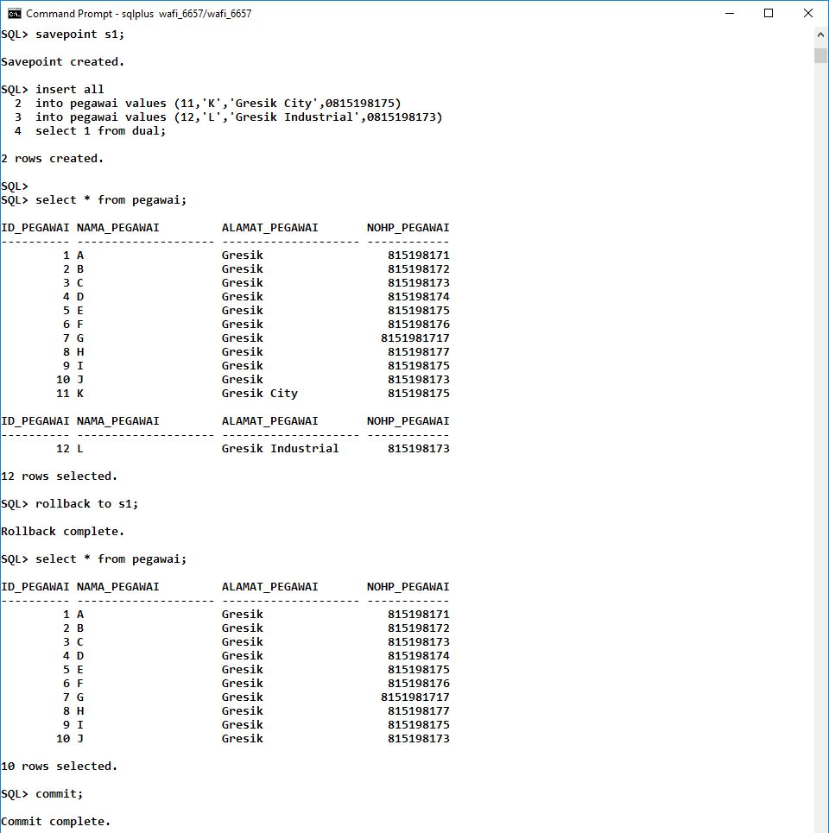

Keterangan Query :

------------------------------------------------------------------------------------------------------------------------------------------------------------------------------------------------------------------------------------------------------------------------------------------------------------------------------------------------------------------------------------------------------------------------------------------------------------------------------------------------------------------------------------------------------------------------------------------------------------------------------------------------------------------------------------------------------------------------------------------------------------------------------------------------------------------------------------------------------------------------------------------------------------------------------------------------------------------------------------------------------------------------------------------------------------------------------------------------------------------------------------------------------------------------------------------------------------------------------------------------------------------------------------------------------------------------------------------------------------------------------------------------------------------------------------------------------------------------------------------------------------------------------------------------------------------------------------------------------------------------------------------------



Keterangan Query :

------------------------------------------------------------------------------------------------------------------------------------------------------------------------------------------------------------------------------------------------------------------------------------------------------------------------------------------------------------------------------------------------------------------------------------------------------------------------------------------------------------------------------------------------------------------------------------------------------------------------------------------------------------------------------------------------------------------------------------------------------------------------------------------------------------------------------------------------------------------------------------------------------------------------------------------------------------------------------------------------------------------------------------------------------------------------------------------------------------------------------------------------------------------------------------------------------------------------------------------------------------------------------------------------------------------------------------------------------------------------------------------------------------------------------------------------------------------------------------------------------------------------------------------------------------------------------------------------------------------------------------------------

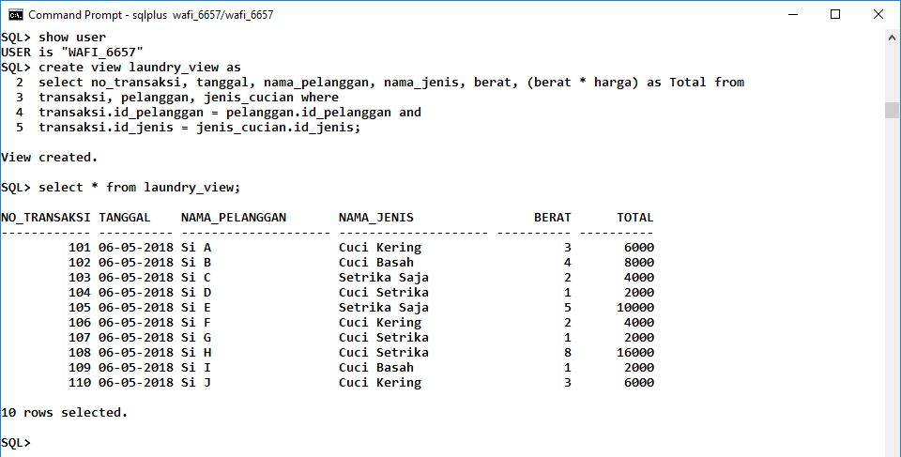

Keterangan Query :

------------------------------------------------------------------------------------------------------------------------------------------------------------------------------------------------------------------------------------------------------------------------------------------------------------------------------------------------------------------------------------------------------------------------------------------------------------------------------------------------------------------------------------------------------------------------------------------------------------------------------------------------------------------------------------------------------------------------------------------------------------------------------------------------------------------------------------------------------------------------------------------------------------------------------------------------------------------------------------------------------------------------------------------------------------------------------------------------------------------------------------------------------------------------------------------------------------------------------------------------------------------------------------------------------------------------------------------------------------------------------------------------------------------------------------------------------------------------------------------------------------------------------------------------------------------------------------------------------------------------------------------------